Multilevel Truncated Negative Binomial Model Results

Fixed Effects Coefficients
Estimate | Std. Error | z value | P-value | Variable
-1.5411 | 2.3560 | -0.6541 | 0.5130 | (Intercept)
-0.0020 | 0.0037 | -0.5476 | 0.5839 | import_from_slu_log
0.0058 | 0.0001 | 47.2777 | 0.0000 | age
-0.0043 | 0.0042 | -1.0050 | 0.3149 | immigrant_density_centered
0.2756 | 0.2149 | 1.2824 | 0.1997 | state_percapita_income_log
0.0052 | 0.0051 | 1.0115 | 0.3118 | immigrant_similar
0.0006 | 0.0043 | 0.1477 | 0.8826 | immigrant_moderate
0.0104 | 0.0035 | 2.9438 | 0.0032 | sex_enc1
0.0040 | 0.0121 | 0.3307 | 0.7409 | marital_status_enc1
0.0040 | 0.0043 | 0.9432 | 0.3456 | marital_status_enc2
-0.0467 | 0.0283 | -1.6496 | 0.0990 | employment_status_enc1
0.1081 | 0.0202 | 5.3383 | 0.0000 | employment_status_enc2
0.1907 | 0.0198 | 9.6462 | 0.0000 | purpose_simple1
0.4483 | 0.0158 | 28.4439 | 0.0000 | purpose_simple2
0.1452 | 0.0136 | 10.6425 | 0.0000 | purpose_simple3
0.0079 | 0.0159 | 0.4949 | 0.6207 | purpose_simple4
0.1306 | 0.0092 | 14.1977 | 0.0000 | accomd_type_enc1
0.2359 | 0.0053 | 44.6193 | 0.0000 | accomd_type_enc2

Incident Rate Ratios (IRR) for Fixed Effects
Incident Rate Ratios for Fixed Effects
Variable | IRR | Lower CI | Upper CI | P-value
(Intercept) | 0.2141 | 0.0021 | 21.6846 | 0.5130
import_from_slu_log | 0.9980 | 0.9907 | 1.0053 | 0.5839
age | 1.0058 | 1.0056 | 1.0061 | 0.0000
immigrant_density_centered | 0.9958 | 0.9875 | 1.0041 | 0.3149
state_percapita_income_log | 1.3173 | 0.8645 | 2.0074 | 0.1997
immigrant_similar | 1.0052 | 0.9952 | 1.0152 | 0.3118
immigrant_moderate | 1.0006 | 0.9922 | 1.0092 | 0.8826
sex_enc1 | 1.0105 | 1.0035 | 1.0175 | 0.0032
marital_status_enc1 | 1.0040 | 0.9805 | 1.0281 | 0.7409
marital_status_enc2 | 1.0040 | 0.9957 | 1.0124 | 0.3456
employment_status_enc1 | 0.9543 | 0.9028 | 1.0088 | 0.0990
employment_status_enc2 | 1.1142 | 1.0708 | 1.1593 | 0.0000
purpose_simple1 | 1.2101 | 1.1641 | 1.2579 | 0.0000
purpose_simple2 | 1.5656 | 1.5180 | 1.6147 | 0.0000
purpose_simple3 | 1.1563 | 1.1258 | 1.1877 | 0.0000
purpose_simple4 | 1.0079 | 0.9769 | 1.0398 | 0.6207
accomd_type_enc1 | 1.1395 | 1.1191 | 1.1602 | 0.0000
accomd_type_enc2 | 1.2661 | 1.2530 | 1.2793 | 0.0000

Random Effects Variance Components
No random effect variance estimated for us_state_enc.

Model R-squared (Marginal and Conditional)
Statistic | Value
R2_conditional | 0.1116
R2_marginal | 0.0723

Variance Inflation Factor (VIF)
VIF Values (Note: VIF > 5 may indicate multicollinearity)
Variable | VIF
Predictor 1 | 1.44
Predictor 2 | 1.11
Predictor 3 | 34.31
Predictor 4 | 1.41
Predictor 5 | 3.07
Predictor 6 | 30.35
Predictor 7 | 1.02
Predictor 8 | 1.17
Predictor 9 | 1.00
Predictor 10 | 1.17
Predictor 11 | 1.15

Model Comparison (Truncated vs Non-truncated)
ANOVA Model Comparison Results
Df | AIC | BIC | logLik | deviance | Chisq | Chi Df | Pr(>Chisq)
20 | 746,000.3 | 746,197.2 | -372,980.2 | 745,960.3
20 | 751,682.9 | 751,879.8 | -375,821.4 | 751,642.9 | 0 | 0 | 1

Model Fit Statistics
Statistic | Value
AIC | 746,000.3
BIC | 746,197.2
Log-likelihood | -372,980.2

Robustness Checks

Robustness Check 1: Purpose × All Immigrant Variables
This model tests whether the effect of immigrant variables varies by tourist purpose.
Interactions test if purpose moderates: (1) immigrant_density_centered, (2) immigrant_similar (climate interaction),
and (3) immigrant_moderate (climate interaction). This allows us to see if immigrant network effects
(or climate-immigrant confounding) differ for leisure vs business travelers.

Full Model Results (All IRR)
Purpose Interaction Model: All Coefficients (IRR)
Variable | IRR | Lower CI | Upper CI | P-value
(Intercept) | 0.2147 | 0.0020 | 22.6702 | 0.5176
import_from_slu_log | 0.9979 | 0.9905 | 1.0053 | 0.5738
age | 1.0058 | 1.0056 | 1.0061 | 0.0000
state_percapita_income_log | 1.3157 | 0.8601 | 2.0125 | 0.2058
sex_enc1 | 1.0104 | 1.0034 | 1.0174 | 0.0034
marital_status_enc1 | 1.0049 | 0.9813 | 1.0290 | 0.6882
marital_status_enc2 | 1.0038 | 0.9955 | 1.0122 | 0.3707
employment_status_enc1 | 0.9536 | 0.9021 | 1.0080 | 0.0933
employment_status_enc2 | 1.1143 | 1.0709 | 1.1593 | 0.0000
accomd_type_enc1 | 1.1403 | 1.1199 | 1.1610 | 0.0000
accomd_type_enc2 | 1.2658 | 1.2527 | 1.2790 | 0.0000
purpose_simple1 | 1.1863 | 1.1318 | 1.2435 | 0.0000
purpose_simple2 | 1.6479 | 1.5892 | 1.7087 | 0.0000
purpose_simple3 | 1.1651 | 1.1294 | 1.2019 | 0.0000
purpose_simple4 | 1.0330 | 0.9957 | 1.0717 | 0.0833
immigrant_density_centered | 0.9880 | 0.9721 | 1.0042 | 0.1458
immigrant_similar | 1.0163 | 0.9983 | 1.0345 | 0.0763
immigrant_moderate | 1.0107 | 0.9941 | 1.0276 | 0.2066
purpose_0_x_immigrant_density | 0.9932 | 0.9773 | 1.0094 | 0.4077
purpose_2_x_immigrant_density | 1.0124 | 0.9975 | 1.0276 | 0.1042
purpose_3_x_immigrant_density | 1.0082 | 0.9942 | 1.0224 | 0.2512
purpose_4_x_immigrant_density | 1.0002 | 0.9857 | 1.0150 | 0.9741
purpose_1_x_immigrant_density | NA | NA | NA | NA
purpose_0_x_immigrant_similar | 1.0062 | 0.9890 | 1.0238 | 0.4810
purpose_2_x_immigrant_similar | 0.9985 | 0.9829 | 1.0145 | 0.8558
purpose_3_x_immigrant_similar | 0.9874 | 0.9729 | 1.0021 | 0.0920
purpose_4_x_immigrant_similar | 1.0050 | 0.9895 | 1.0208 | 0.5278
purpose_1_x_immigrant_similar | NA | NA | NA | NA
purpose_0_x_immigrant_moderate | 1.0047 | 0.9882 | 1.0215 | 0.5769
purpose_2_x_immigrant_moderate | 0.9838 | 0.9690 | 0.9989 | 0.0350
purpose_3_x_immigrant_moderate | 0.9898 | 0.9758 | 1.0040 | 0.1573
purpose_4_x_immigrant_moderate | 0.9957 | 0.9809 | 1.0106 | 0.5677
purpose_1_x_immigrant_moderate | NA | NA | NA | NA

Model Fit Statistics
Statistic | Value
AIC | 745,971.3
BIC | 746,286.3
Log-likelihood | -372,953.6

Robustness Check 2: Accommodation × All Immigrant Variables
This model tests whether the effect of immigrant variables varies by accommodation type.
Interactions test if accommodation moderates: (1) immigrant_density_centered, (2) immigrant_similar (climate interaction),
and (3) immigrant_moderate (climate interaction). Tourists staying with friends/relatives or in shared platforms
(Airbnb) might show different patterns than hotel guests.

Full Model Results (All IRR)
Accommodation Interaction Model: All Coefficients (IRR)
Variable | IRR | Lower CI | Upper CI | P-value
(Intercept) | 0.2270 | 0.0022 | 23.5339 | 0.5312
import_from_slu_log | 0.9980 | 0.9907 | 1.0054 | 0.5917
age | 1.0058 | 1.0056 | 1.0061 | 0.0000
state_percapita_income_log | 1.3096 | 0.8576 | 1.9998 | 0.2118
sex_enc1 | 1.0106 | 1.0036 | 1.0176 | 0.0029
marital_status_enc1 | 1.0037 | 0.9802 | 1.0277 | 0.7628
marital_status_enc2 | 1.0037 | 0.9954 | 1.0122 | 0.3793
employment_status_enc1 | 0.9566 | 0.9049 | 1.0112 | 0.1172
employment_status_enc2 | 1.1143 | 1.0710 | 1.1594 | 0.0000
purpose_simple1 | 1.1958 | 1.1503 | 1.2431 | 0.0000
purpose_simple2 | 1.5539 | 1.5066 | 1.6027 | 0.0000
purpose_simple3 | 1.1586 | 1.1280 | 1.1900 | 0.0000
purpose_simple4 | 1.0099 | 0.9789 | 1.0419 | 0.5359
accomd_type_enc1 | 1.1548 | 1.1298 | 1.1804 | 0.0000
accomd_type_enc2 | 1.2807 | 1.2646 | 1.2970 | 0.0000
immigrant_density_centered | 0.9971 | 0.9875 | 1.0067 | 0.5519
immigrant_similar | 1.0064 | 0.9951 | 1.0179 | 0.2680
immigrant_moderate | 0.9989 | 0.9891 | 1.0089 | 0.8302
accomd_0_x_immigrant_density | 0.9970 | 0.9920 | 1.0020 | 0.2346
accomd_2_x_immigrant_density | 1.0059 | 1.0004 | 1.0115 | 0.0360
accomd_1_x_immigrant_density | NA | NA | NA | NA
accomd_0_x_immigrant_similar | 0.9995 | 0.9940 | 1.0051 | 0.8688
accomd_2_x_immigrant_similar | 0.9955 | 0.9894 | 1.0016 | 0.1473
accomd_1_x_immigrant_similar | NA | NA | NA | NA
accomd_0_x_immigrant_moderate | 1.0031 | 0.9978 | 1.0083 | 0.2514
accomd_2_x_immigrant_moderate | 0.9962 | 0.9905 | 1.0019 | 0.1916
accomd_1_x_immigrant_moderate | NA | NA | NA | NA

Model Fit Statistics
Statistic | Value
AIC | 745,943.7
BIC | 746,199.6
Log-likelihood | -372,945.8

Interpretation of Robustness Checks
These robustness checks test whether tourist purpose or accommodation type moderates
the relationship between immigrant variables and length of stay. Each model includes
interactions with: (1) immigrant_density_centered (main effect), (2) immigrant_similar
(climate interaction), and (3) immigrant_moderate (climate interaction).
Non-significant interactions would indicate that immigrant effects (or climate-immigrant
confounding) are consistent across purposes and accommodation types. Significant interactions
would suggest heterogeneous effects - for example, if Airbnb guests show stronger
immigrant network effects than hotel guests, or if leisure travelers respond differently
to climate-immigrant patterns than business travelers.

Main Model Diagnostics

Predicted vs Observed Length of Stay
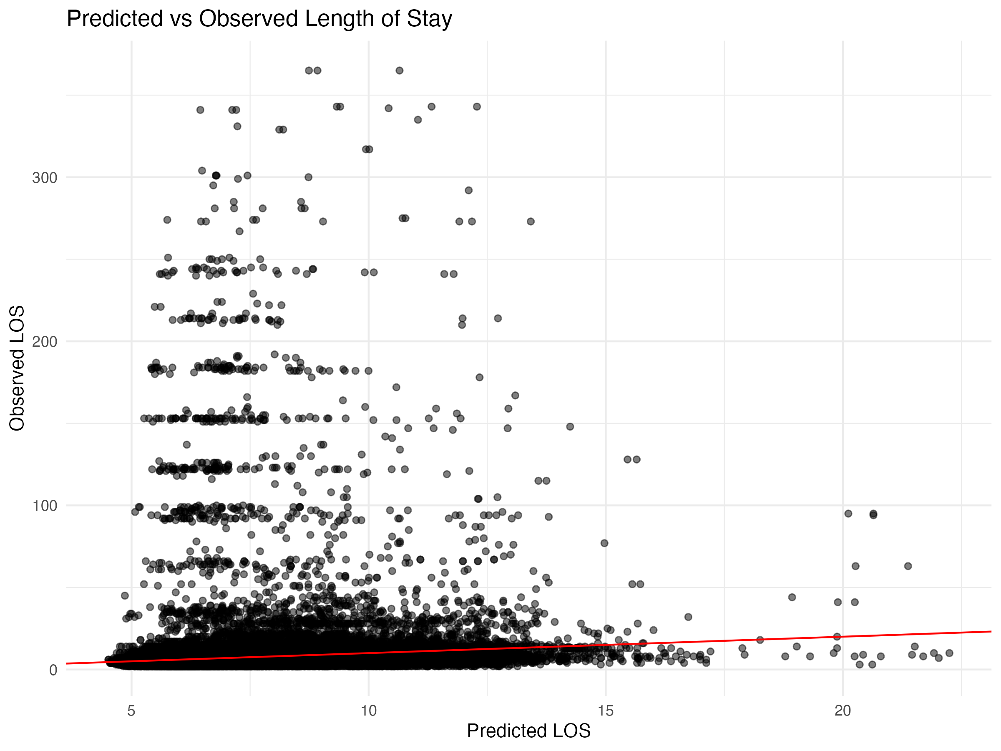

Diagnostic Plots

DHARMa Residuals
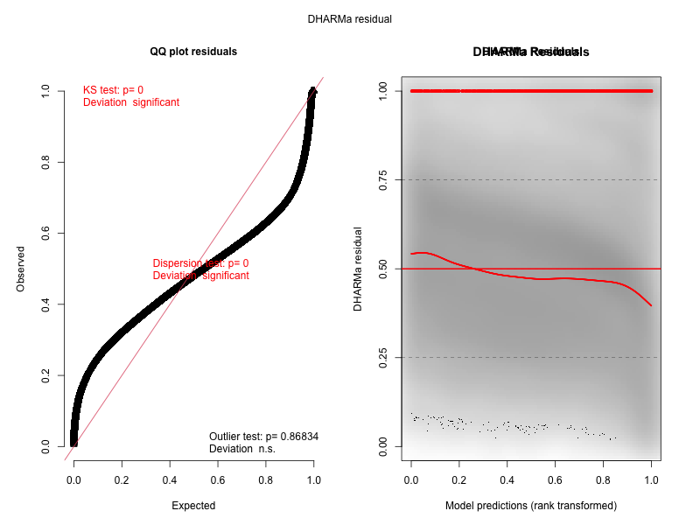

Residuals by State
